**Team: Nutrition Nuts**

**Members:** Duong Nguyen ❄ Jerry Reyes ❄ Meera Shah ❄ Tan Duong ❄ Tasneem Bhaijee

**Project Title:** Fruits and Veggies are Fruity-licious!

**Problem:** How Nutritious are Fruits and Vegetables?

**Proposal:**

Using Tensorflow, we will use image classifications of fruits and vegetables from the ImageNet dataset to identify the fruits/vegetables. After identification of the fruit/vegetable, a nutrition table will display with API data pulled from the USDA Agricultural Research Service. We will also use Tableau or a form of D3 to create chart analysis of certain nutrition data that compares the 10 different common fruits and/or vegetables, such as relative sugar content. A drop down menu will allow the user to select between different types of nutritions to look up.

An app will be created to allow an upload of a picture of a fruit or vegetable from the user, and a search option to enter the name of fruit instead, if the user chooses to do so. An example of the app and JSON data is below:

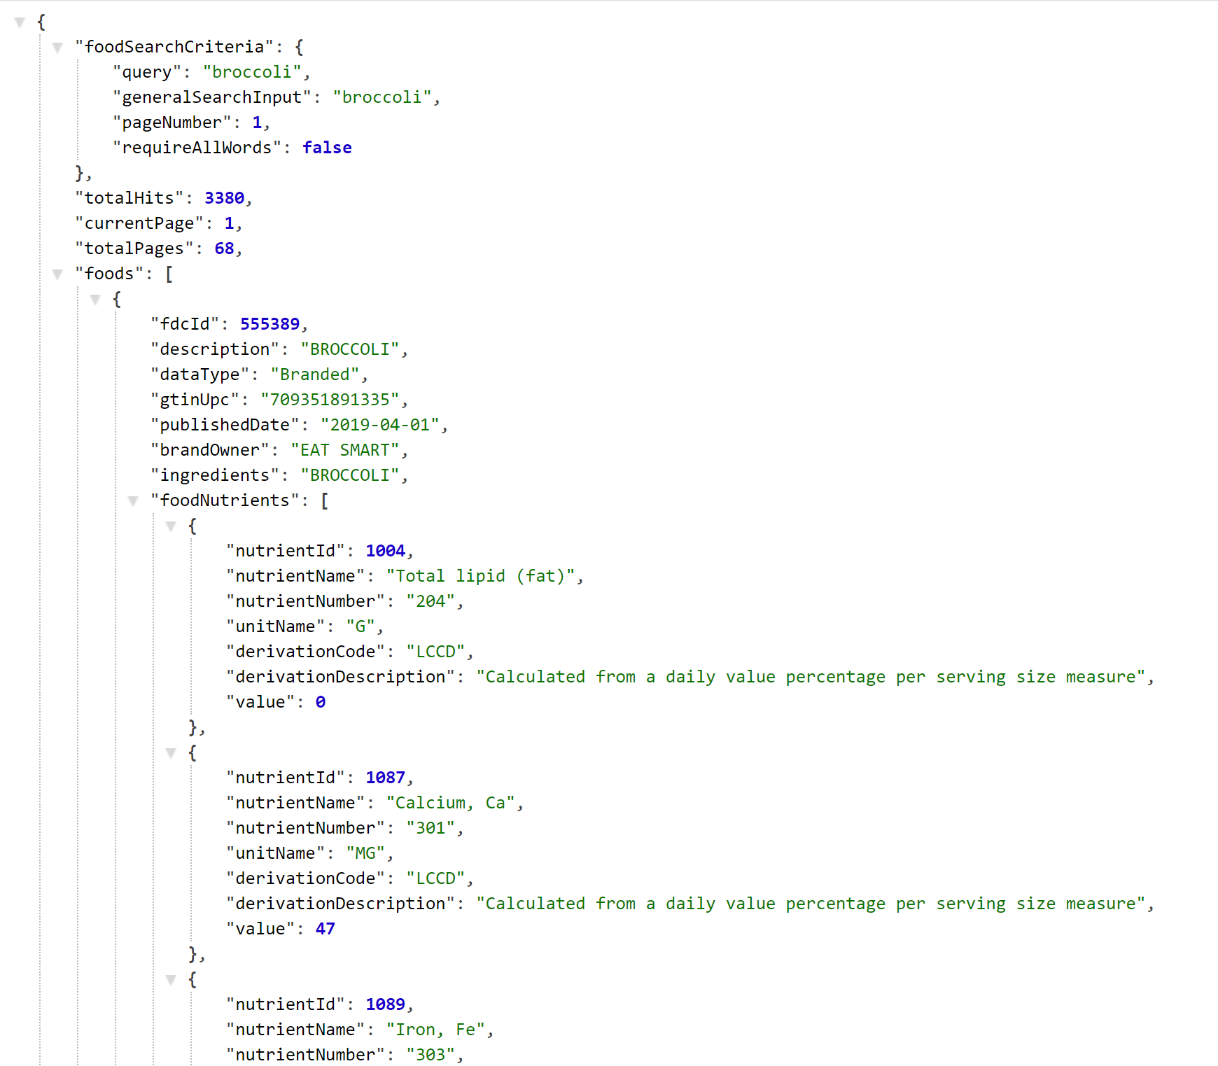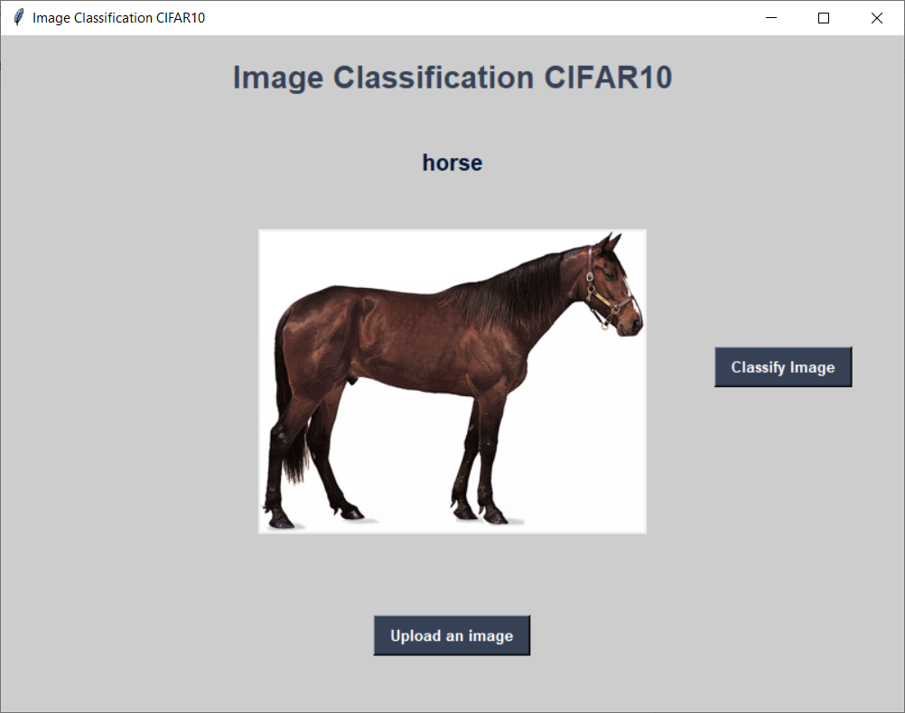

We are planning to use TensorFlow, Keras, Flask, Google Collab, Python, D3, Tableau, Heroku (or another hosting site), MatPlotLib, and HTML/CSS.